Evaluation: Random Forest
Accuracy: 0.934260429835651
Precision: 0.9520711025523029
Recall: 0.934260429835651
F1 Score: 0.9395416422558663
Jaccard Index: 0.8968601435157353
Matthews CorrCoef: 0.9175659775673616
Cohen’s Kappa: 0.915241384426439
Specificity: 0.9900943367170946
AUC: 1.0
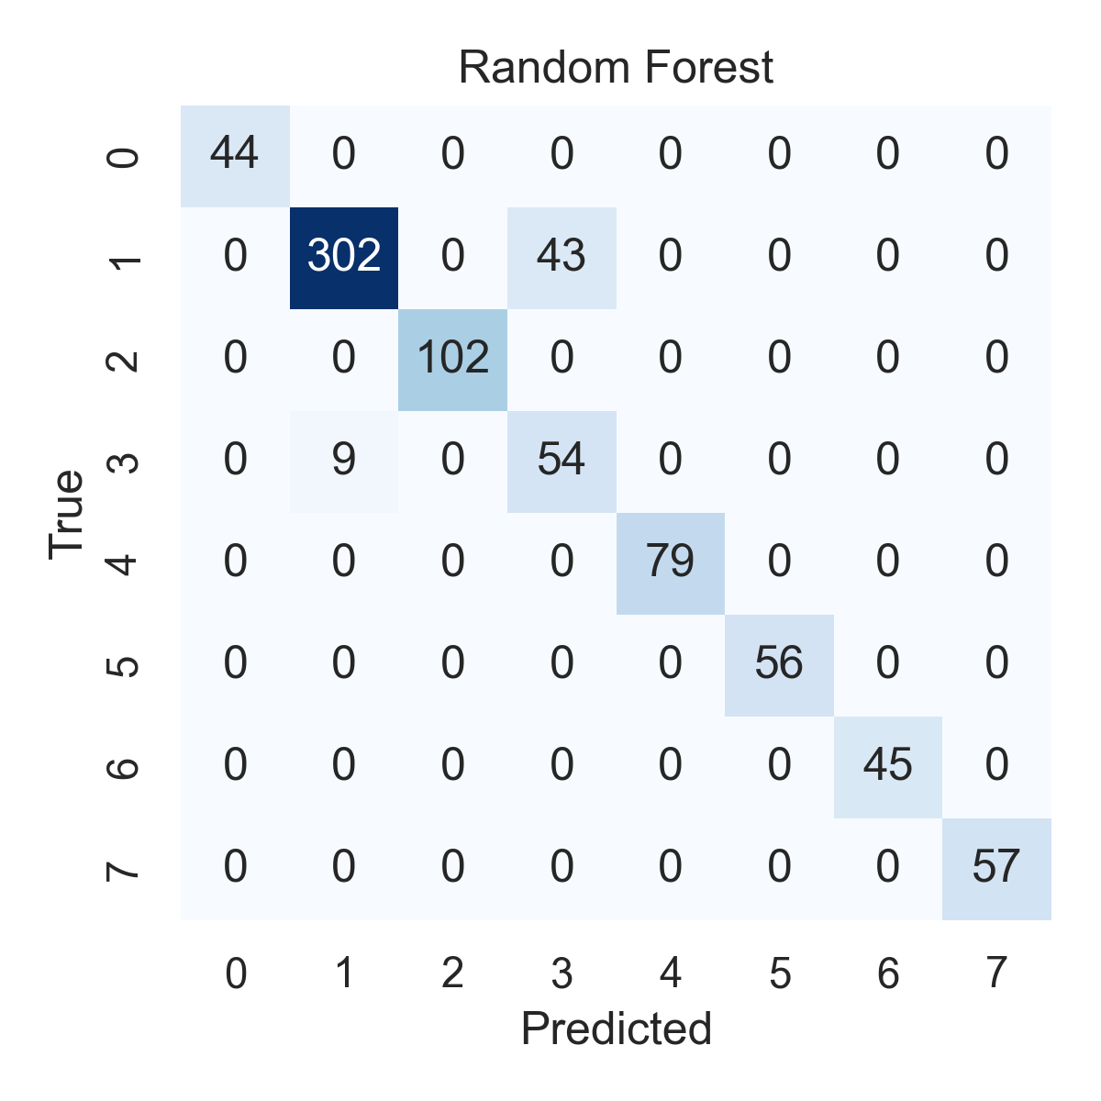

Combined ROC Curves
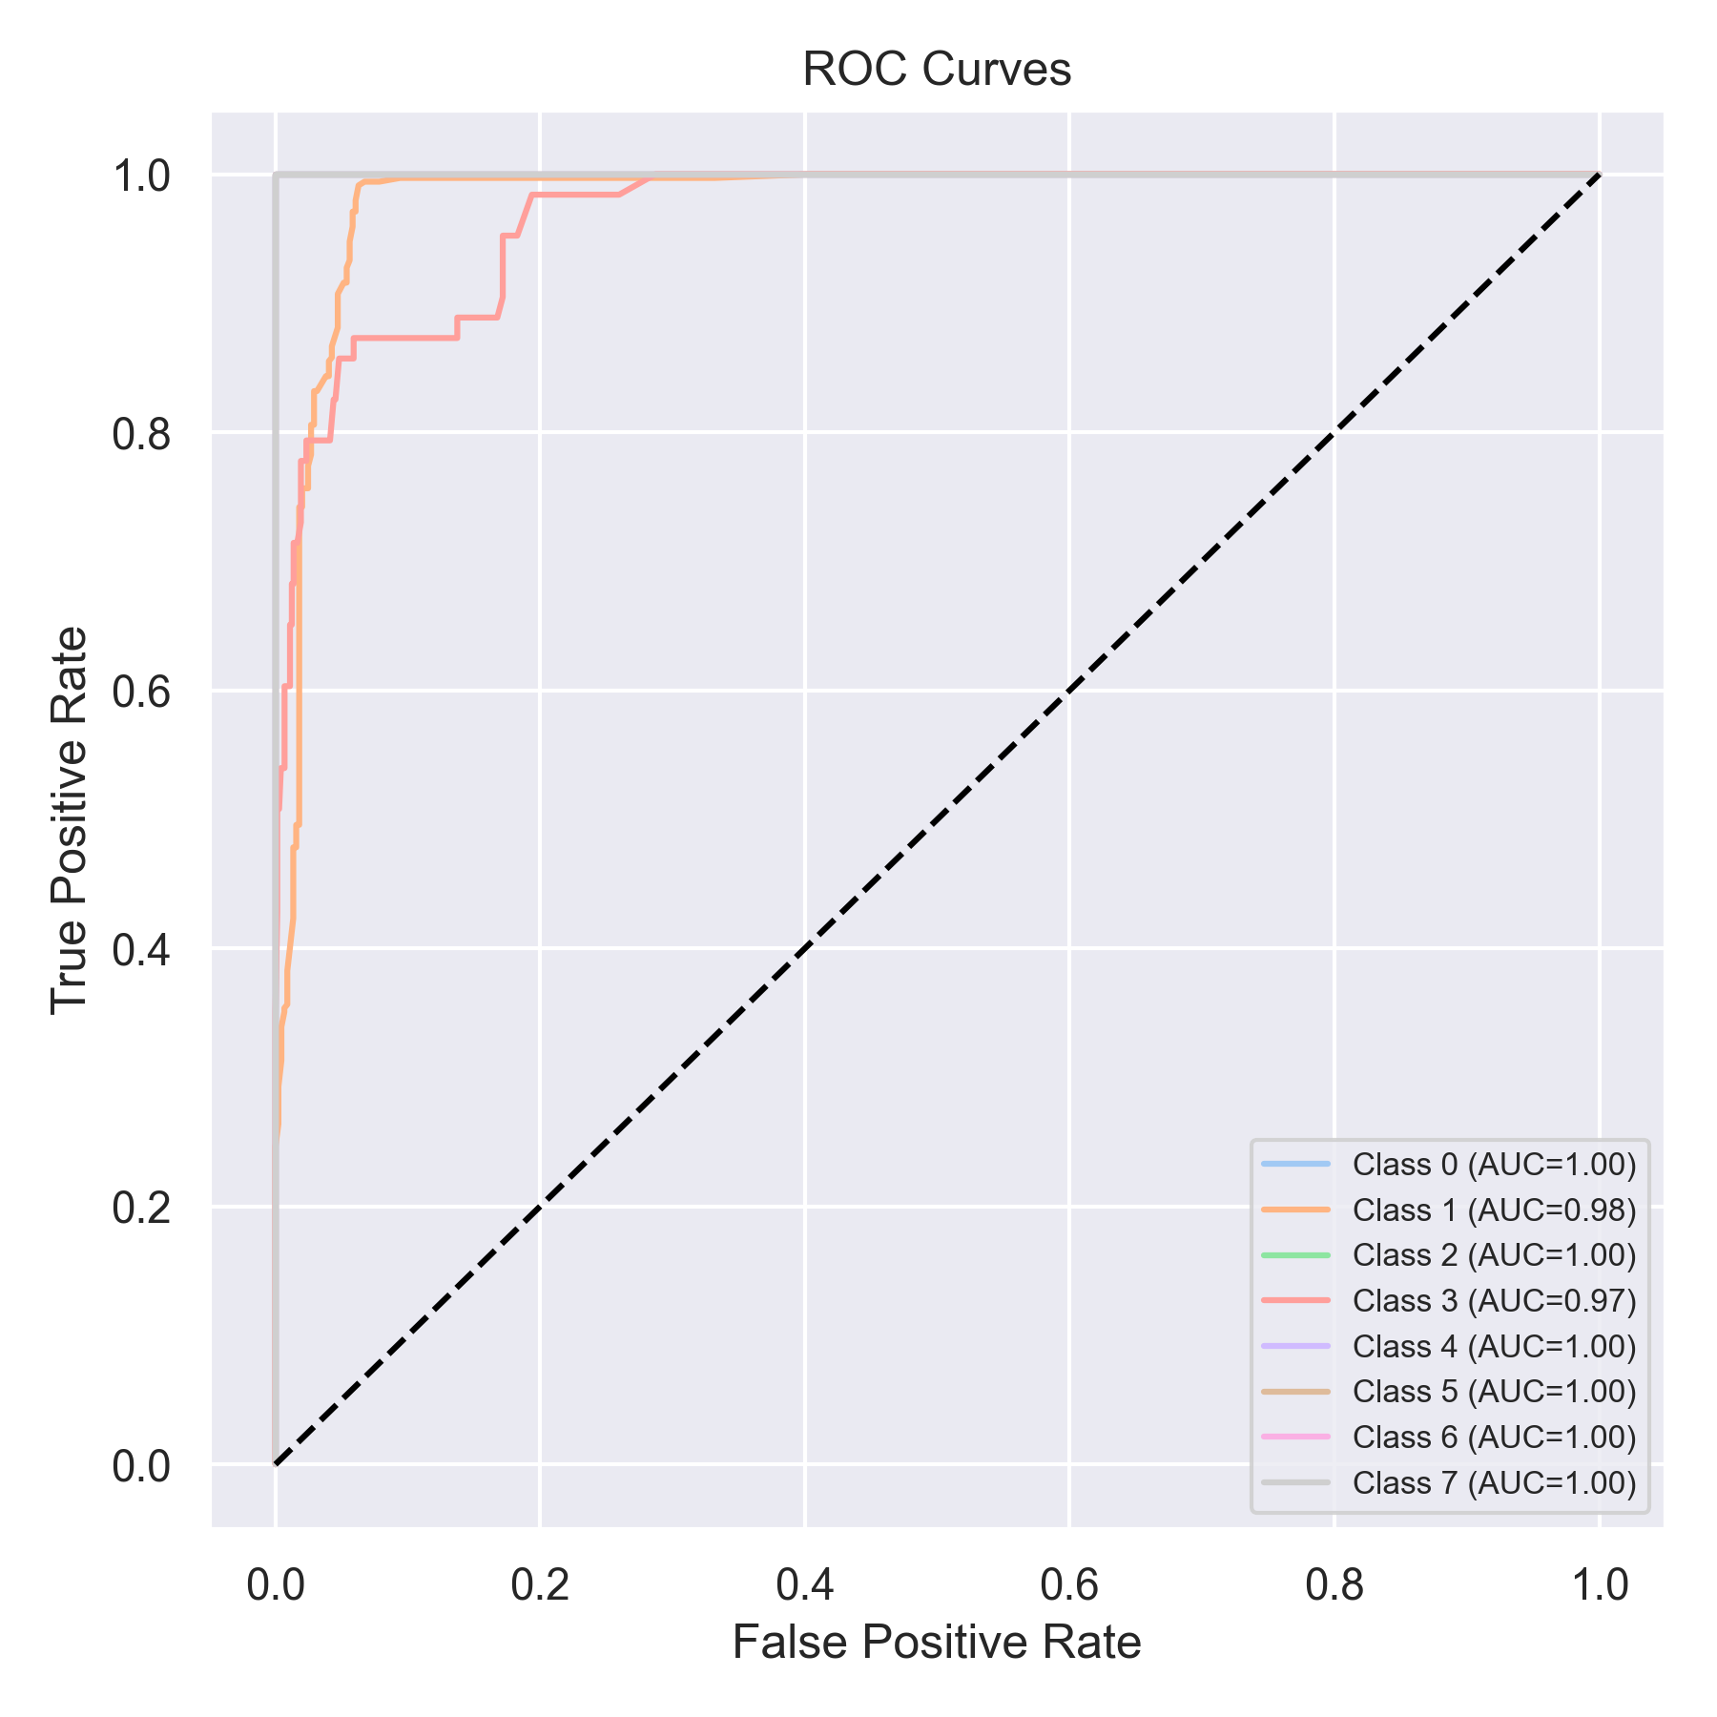

Evaluation: K-Nearest Neighbors
Accuracy: 0.695322376738306
Precision: 0.7633957341196524
Recall: 0.695322376738306
F1 Score: 0.6952620117653379
Jaccard Index: 0.5357727841311957
Matthews CorrCoef: 0.650101778887594
Cohen’s Kappa: 0.6322491656538765
Specificity: 0.9569502372796359
AUC: 0.9888976528514748
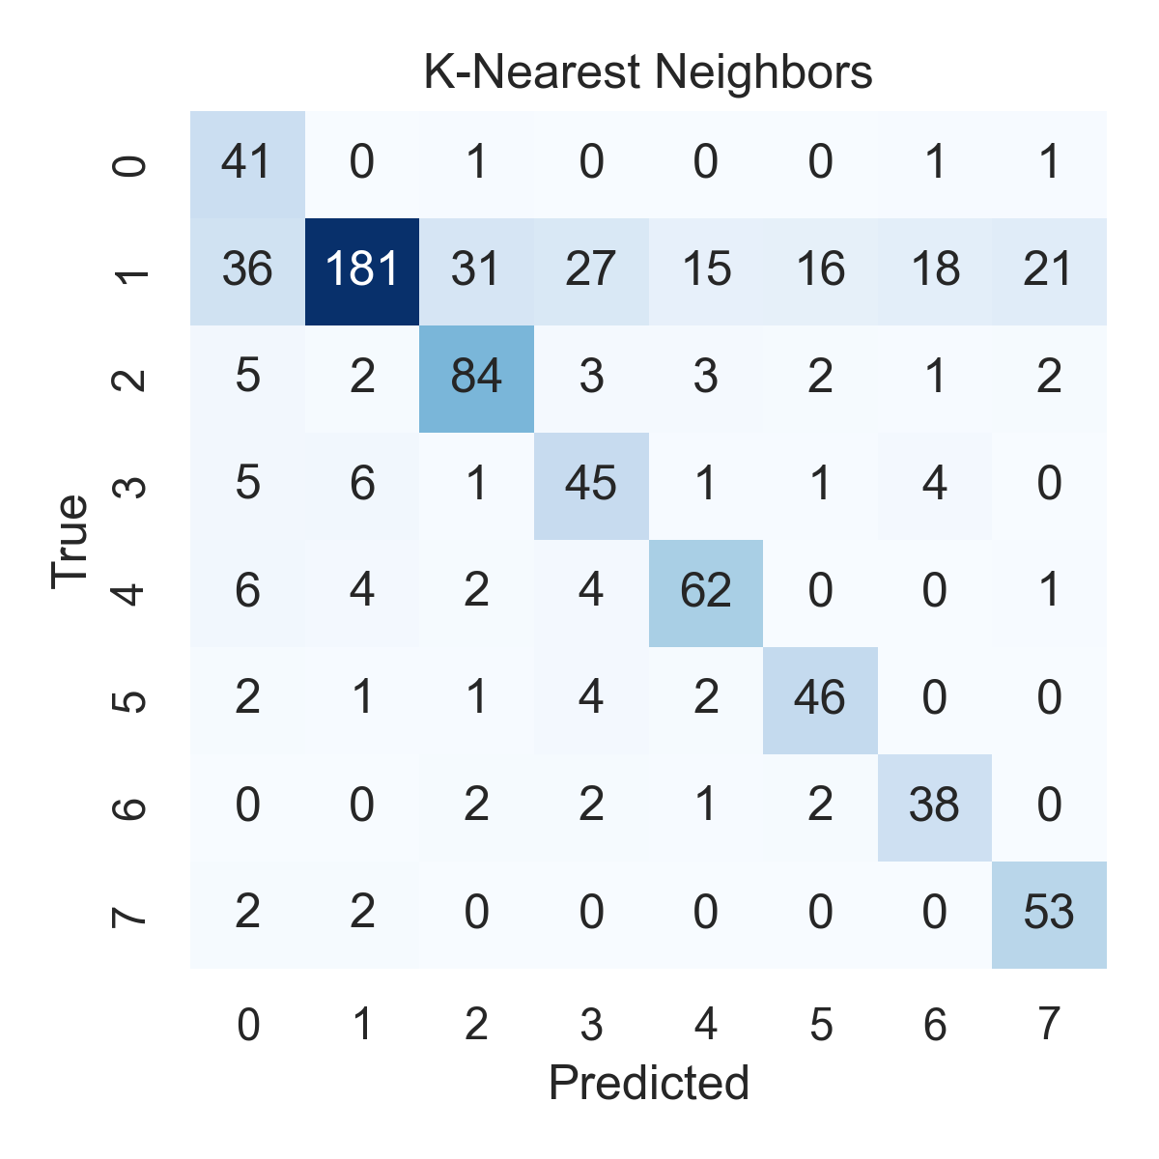

Combined ROC Curves
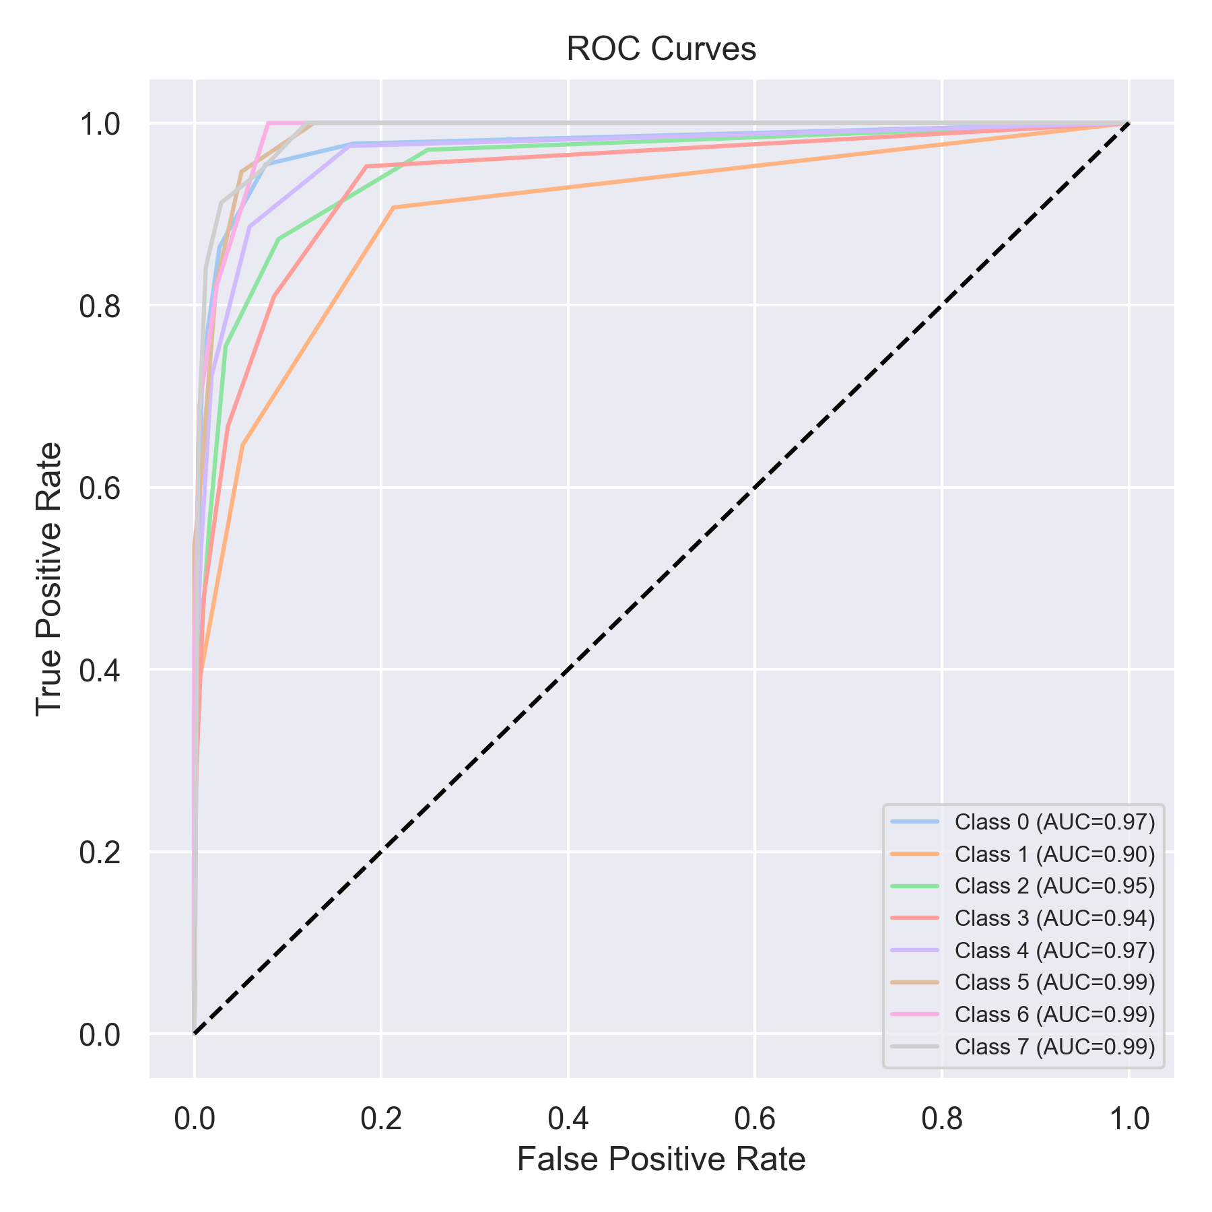

Evaluation: Decision Tree
Accuracy: 0.7724399494310998
Precision: 0.8835243779414936
Recall: 0.7724399494310998
F1 Score: 0.8038636031202175
Jaccard Index: 0.7223217329202727
Matthews CorrCoef: 0.7462632293670308
Cohen’s Kappa: 0.7218010441741958
Specificity: 0.9662706967919972
AUC: 1.0
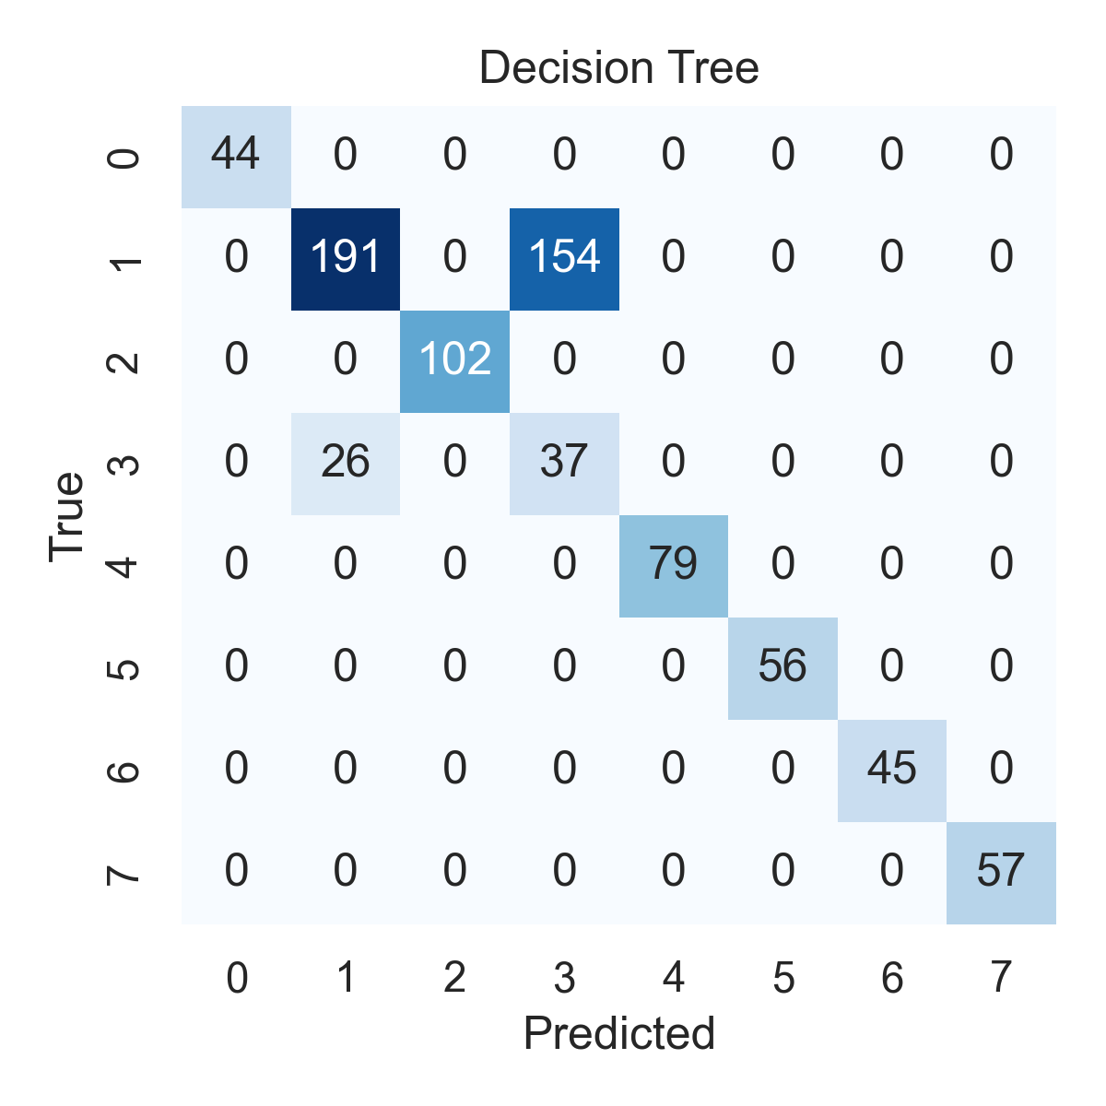

Combined ROC Curves
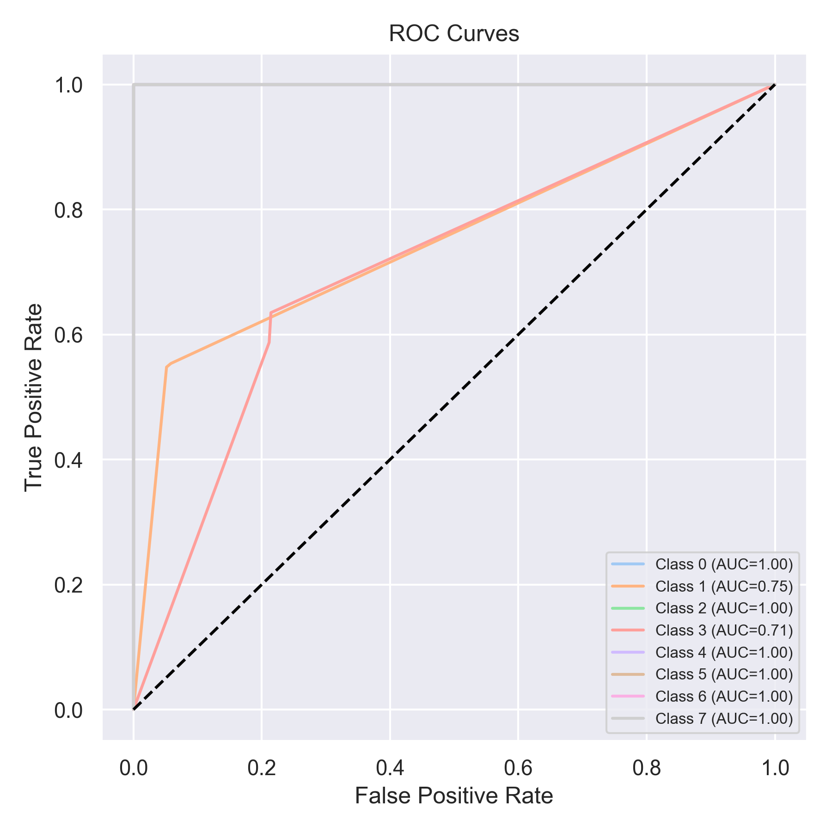

Evaluation: Extra Trees
Accuracy: 0.9671302149178256
Precision: 0.9677937740049914
Recall: 0.9671302149178256
F1 Score: 0.9674074850871156
Jaccard Index: 0.9410447145279653
Matthews CorrCoef: 0.9568981523182402
Cohen’s Kappa: 0.9568694149499508
Specificity: 0.9943431261776874
AUC: 1.0
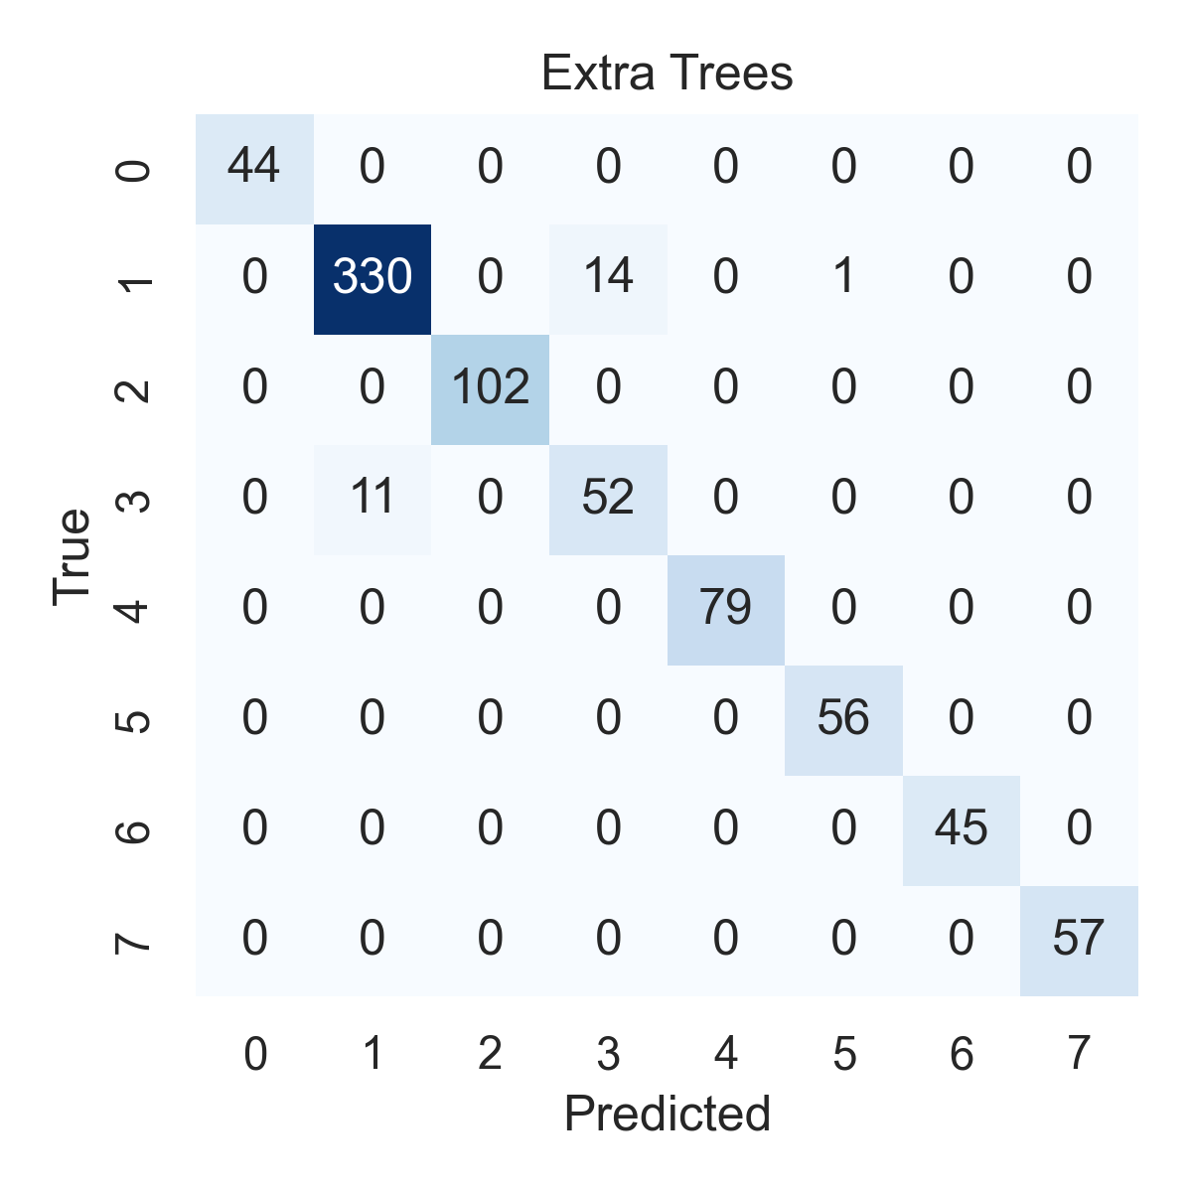

Combined ROC Curves
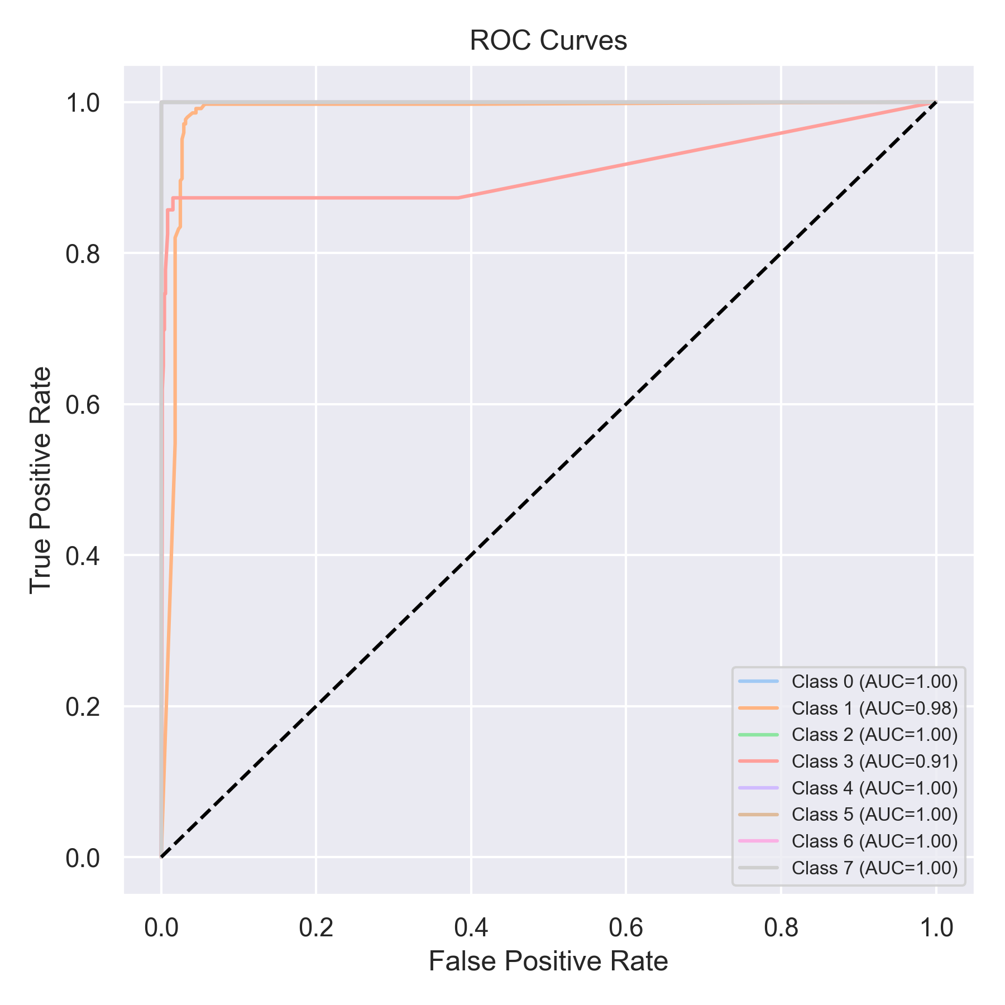

Evaluation: Bagging Classifier
Accuracy: 0.7711757269279393
Precision: 0.8827117754647674
Recall: 0.7711757269279393
F1 Score: 0.8019999587342815
Jaccard Index: 0.7181155992237445
Matthews CorrCoef: 0.7453981189499853
Cohen’s Kappa: 0.7204188318091902
Specificity: 0.9661033607812877
AUC: 1.0
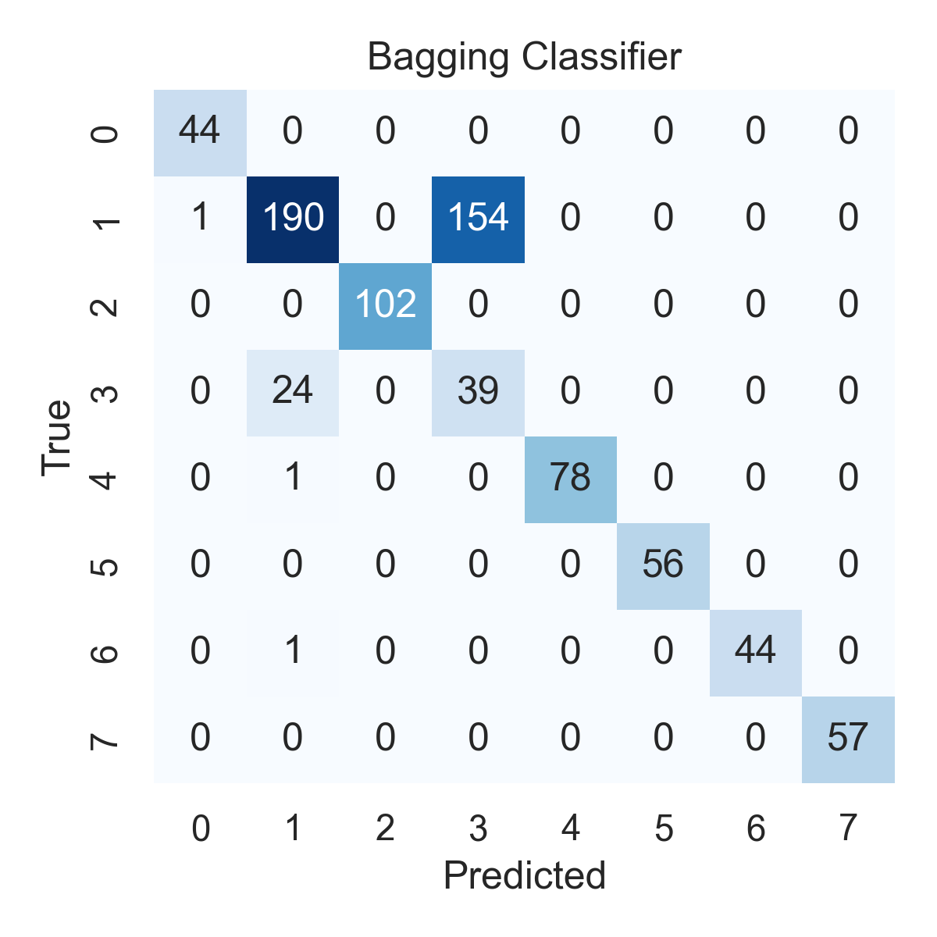

Combined ROC Curves
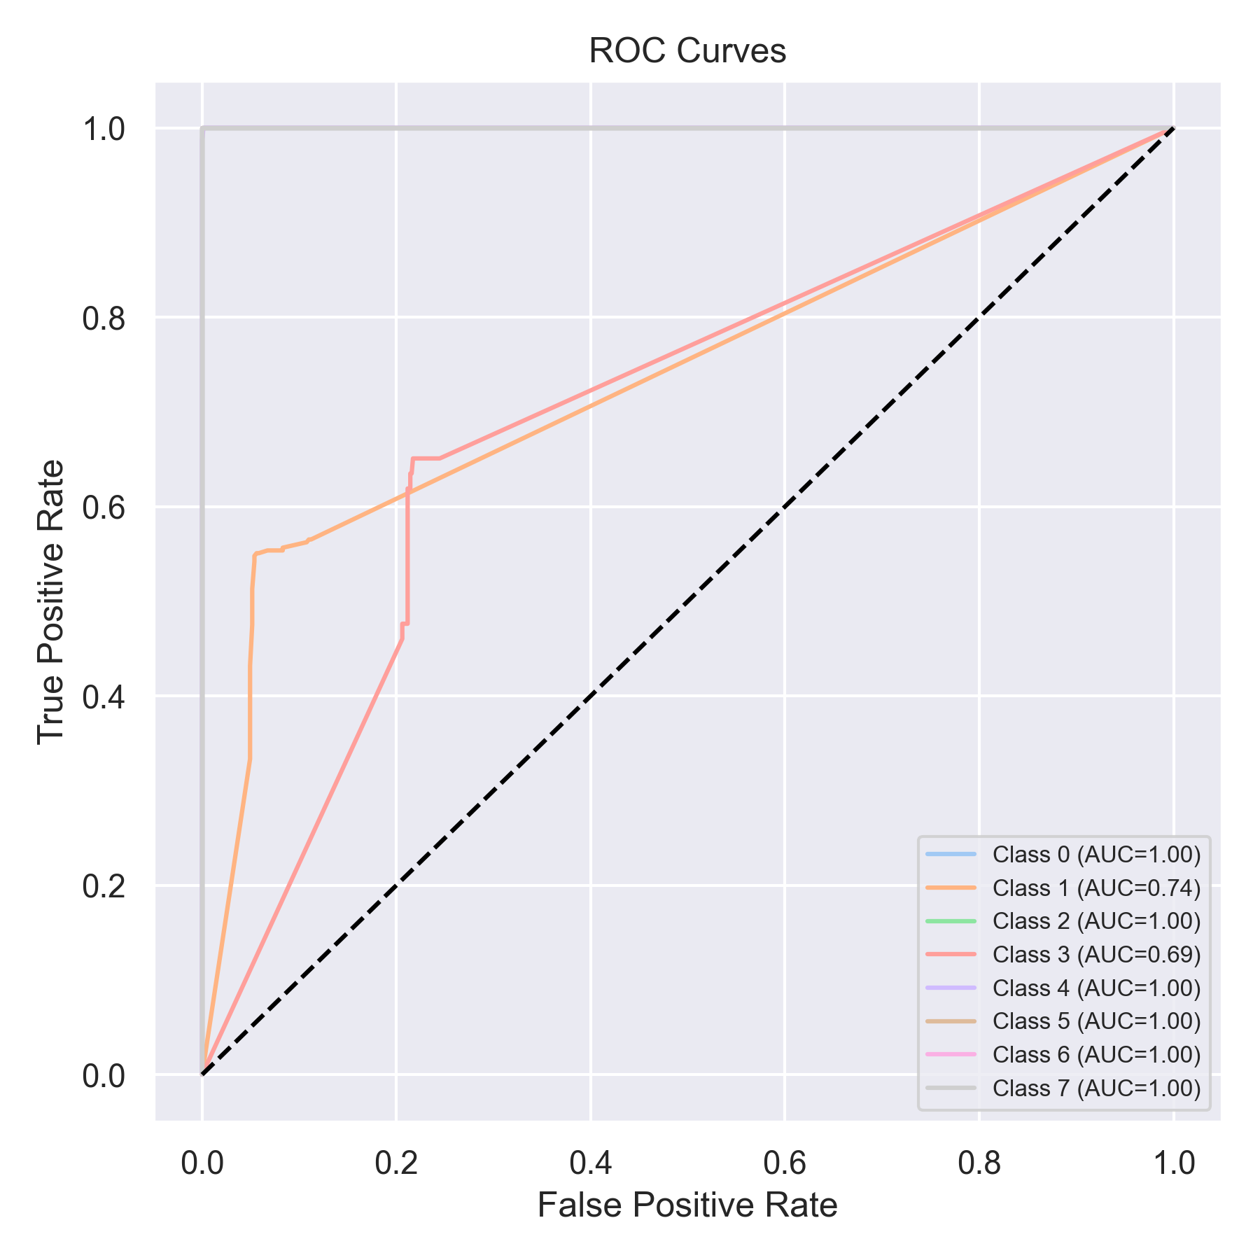

Evaluation: XGBoost
Accuracy: 0.7724399494310998
Precision: 0.8871387617741849
Recall: 0.7724399494310998
F1 Score: 0.8037372807171452
Jaccard Index: 0.7217781228259956
Matthews CorrCoef: 0.7484141014222555
Cohen’s Kappa: 0.7224128519067301
Specificity: 0.9664878283151825
AUC: 1.0
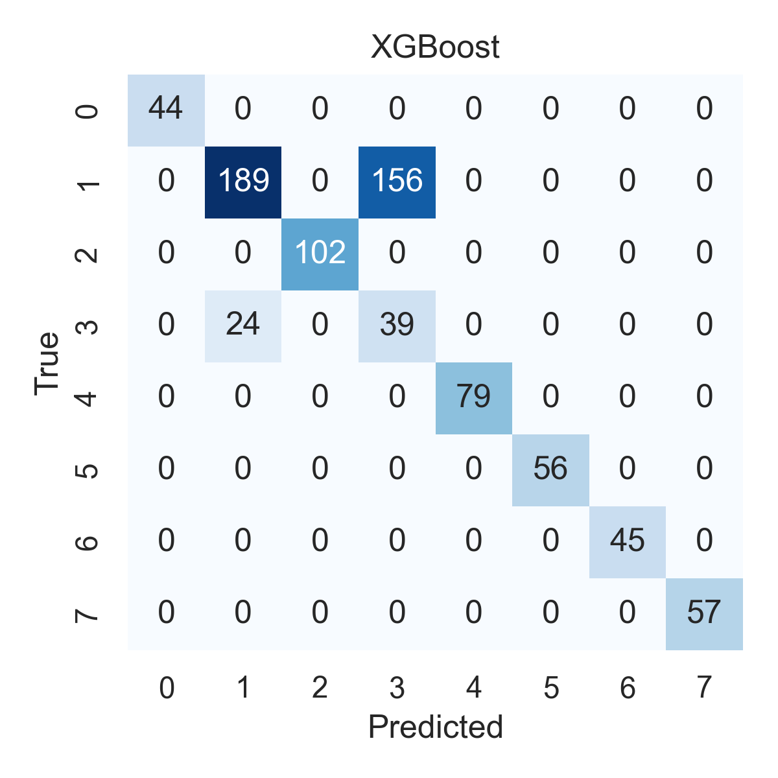

Combined ROC Curves
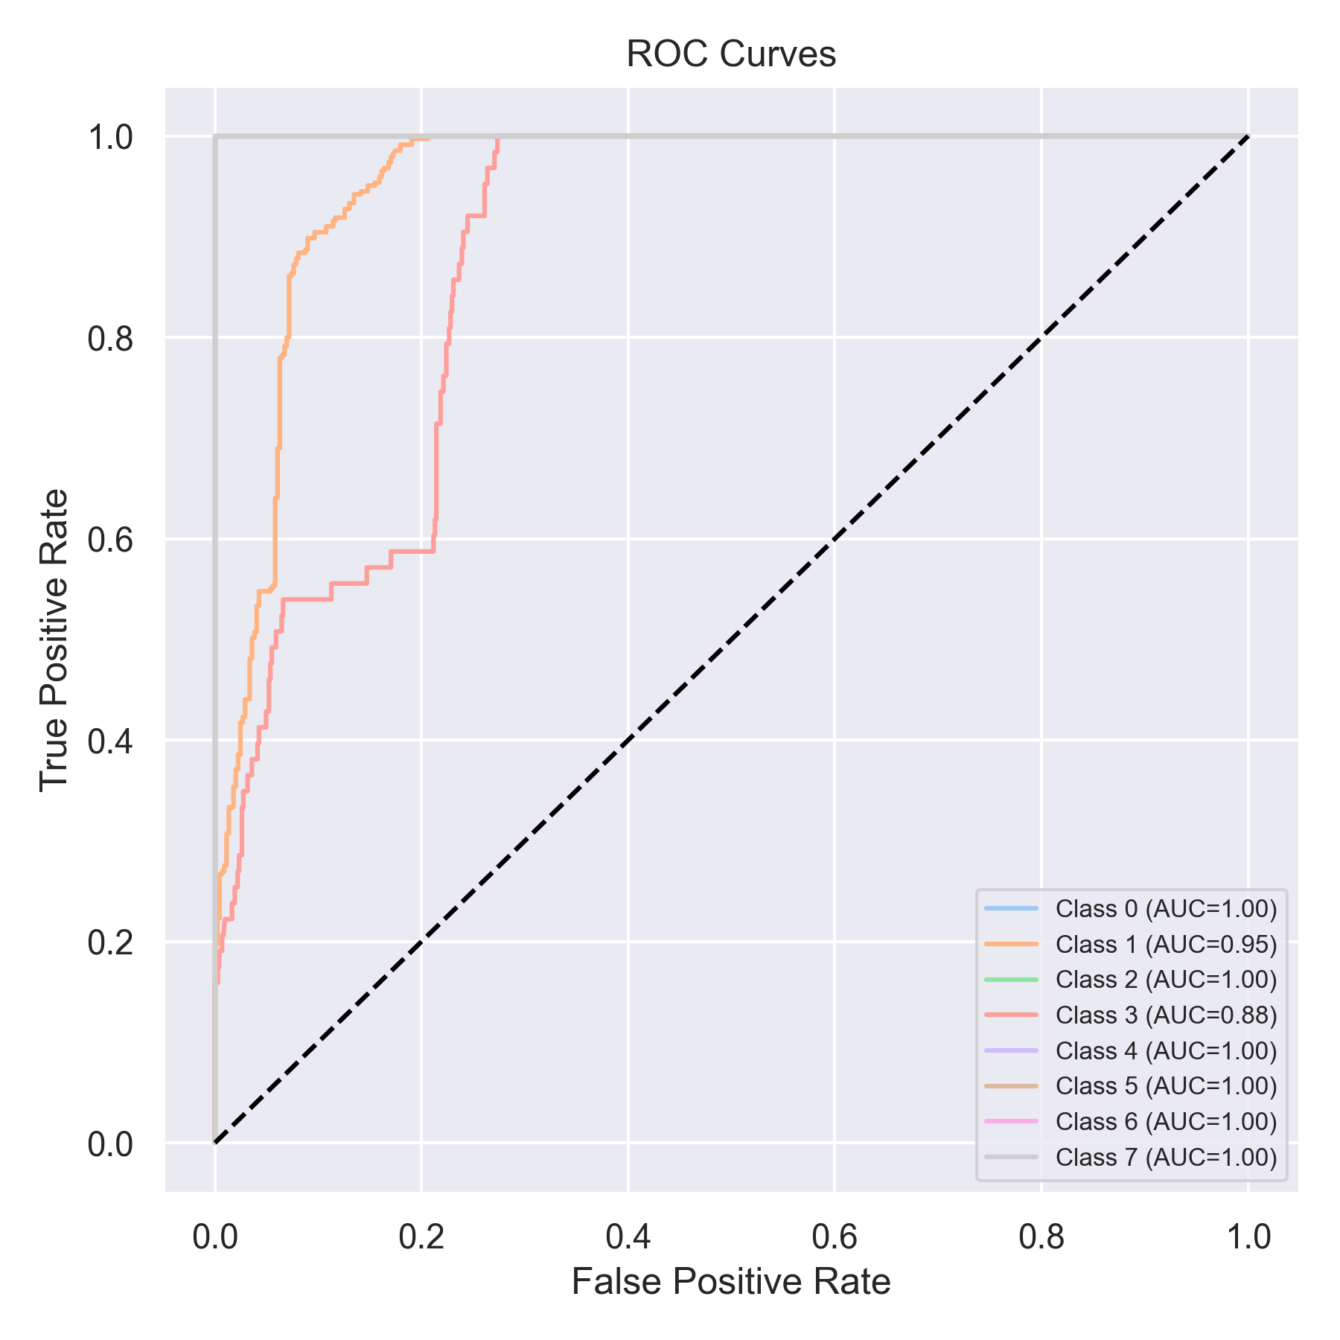

Evaluation: LightGBM
Accuracy: 0.8141592920353983
Precision: 0.8986667027247254
Recall: 0.8141592920353983
F1 Score: 0.8395689984915053
Jaccard Index: 0.7631648999100847
Matthews CorrCoef: 0.7857995479511705
Cohen’s Kappa: 0.7693731182241192
Specificity: 0.972262602867984
AUC: 1.0
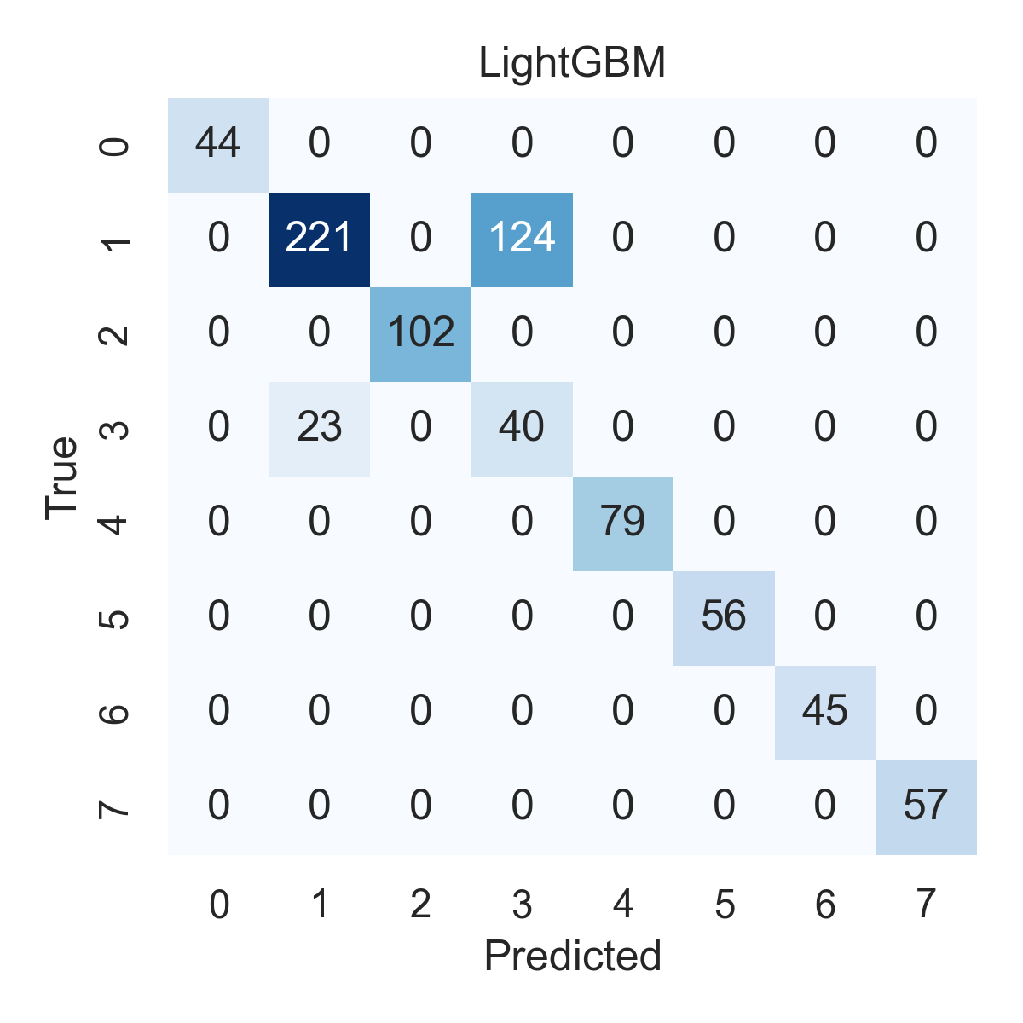

Combined ROC Curves
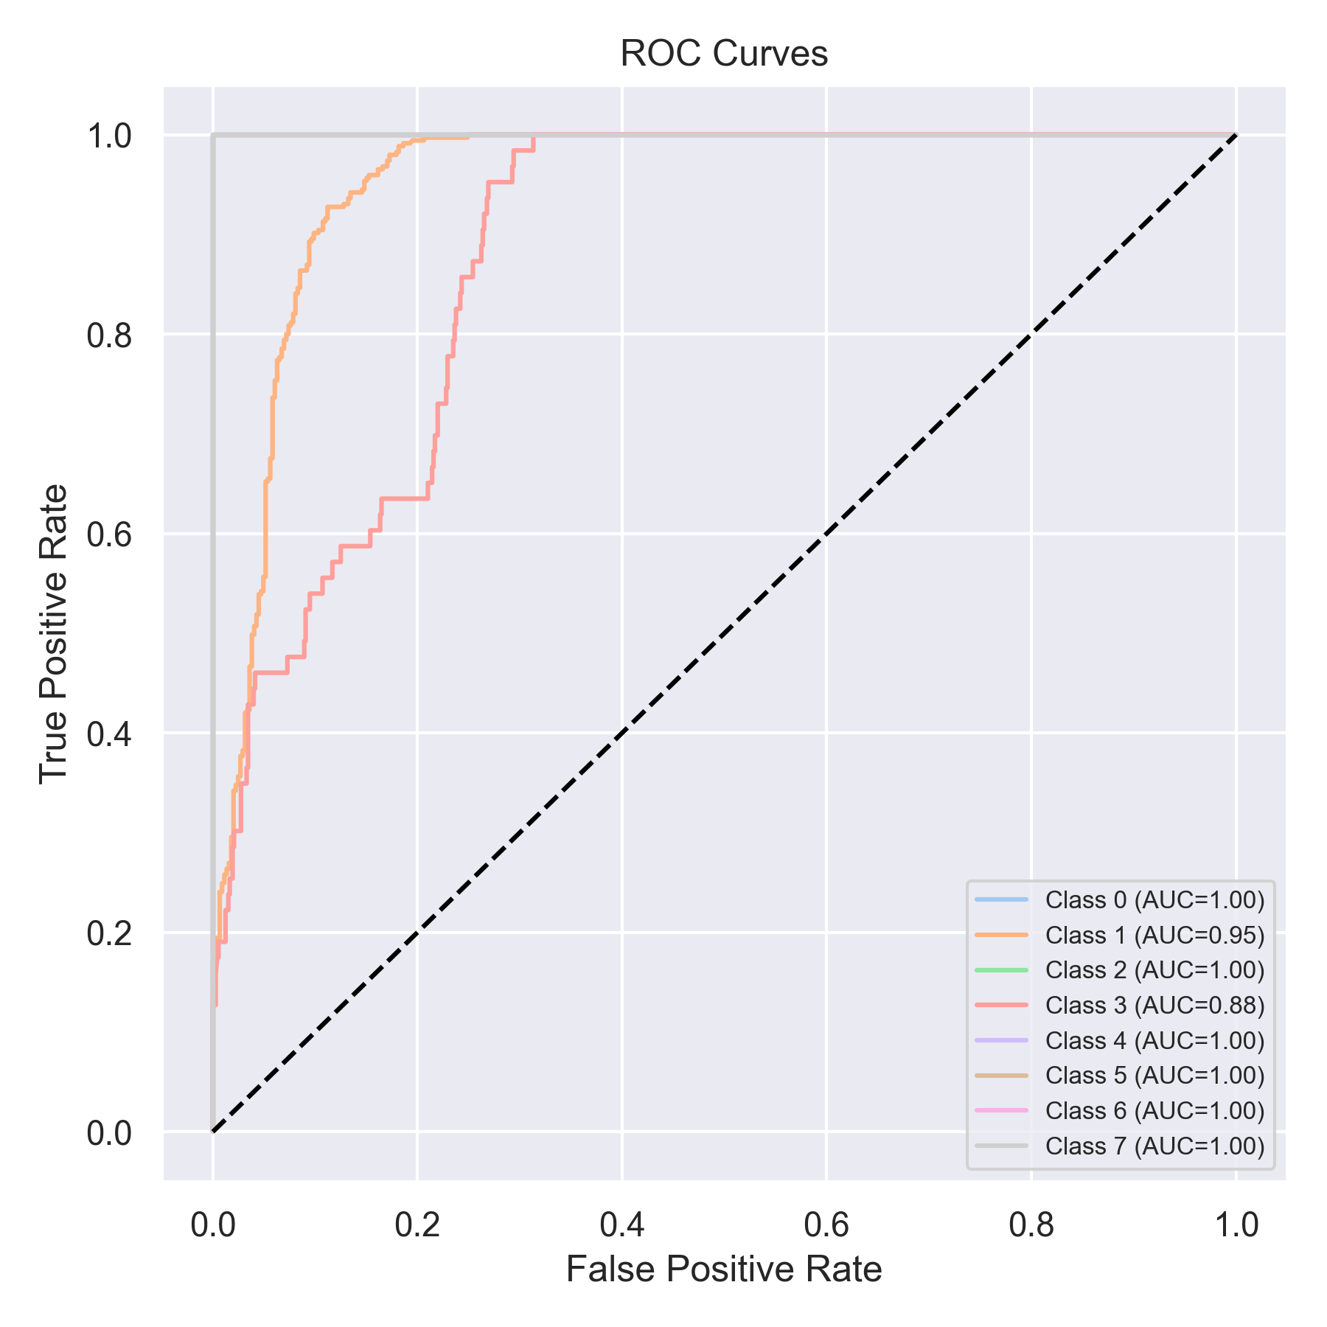

Evaluation: CatBoost
Accuracy: 0.05562579013906448
Precision: 0.0030942285285952427
Recall: 0.05562579013906448
F1 Score: 0.005862358721242723
Jaccard Index: 0.0030942285285952427
Matthews CorrCoef: 0.0
Cohen’s Kappa: 0.0
Specificity: 0.875
AUC: 1.0
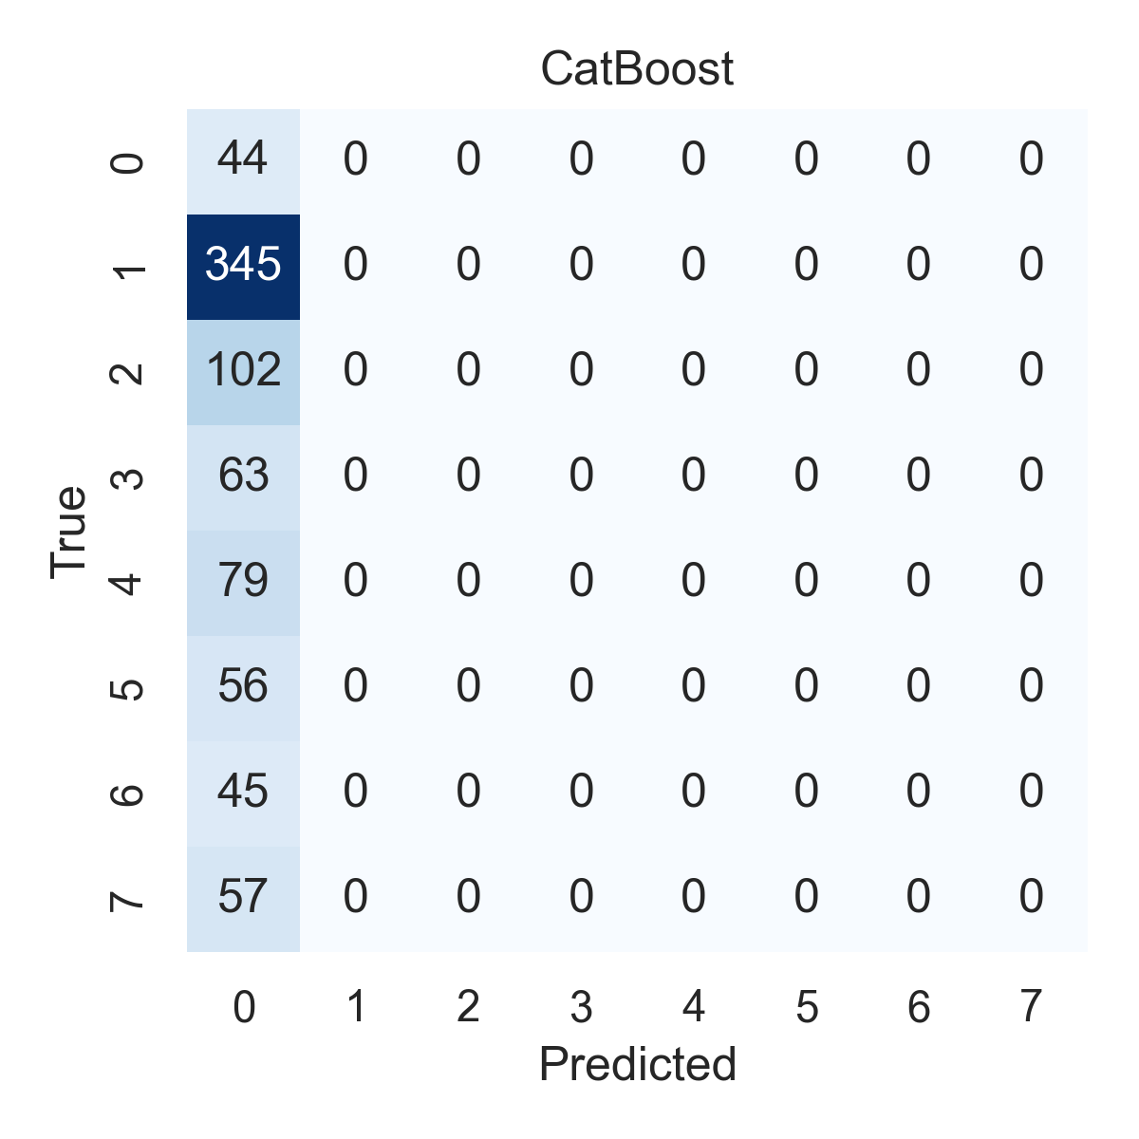

Combined ROC Curves
